Hope this e-mail finds you well and healthy. The Animal Bioscience Forum 2020 (AB 2020) will be held on December 9-10, 2020. We invited outstanding scientists working in the field of animal nutrition and immunology from Korea, USA, Japan, and Australia, to discuss the latest research trends and visions of animal science and biotechnology.
The real-time streaming virtual forum will be held on December 09 and 10, 2020 for two hours each (10:00 am - 12:00 pm). If you would like to participate, you must register through the link below. The program is free-of-charge and see the post for the program in detail.
For inquiries, please contact Keesun Yu, Animal Immunology, Department of Agricultural Biotechnology, Seoul National University (02-880-4813, ksyu206@snu.ac.kr).

The Animal Bioscience Forum 2020 (AB 2020)
Schedule: December 09, 2020 10:00-12:00 (KST) / December 10, 2020 10:00-12:00 (KST)
Link for the Registration: https://us02web.zoom.us/webinar/register/WN_i2TrKO7xTI23-fi1XmN0pQ
QR code for the Registration
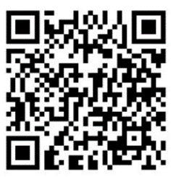

Register is available now and webinar access will be available from 09:45 AM, Dec 09 and 10, 2020 (KST)

